**Karachi:**

RAS MUARI

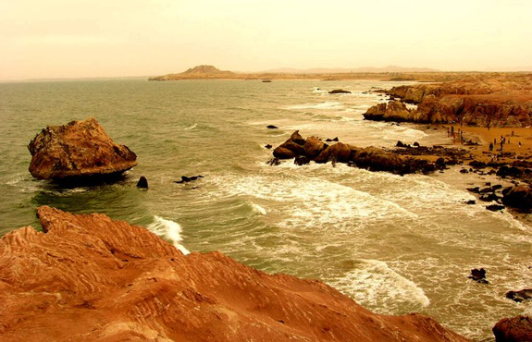

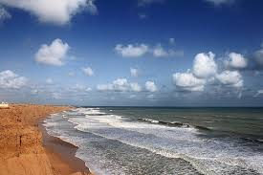

**Ras Muari**, often referred to as Cape Monze, is a beach located off the shore of the Arabian Sea in Karachi. It stretches from the village of Mubarak to Yousuf Goth (Pacha) in West Karachi, Sindh, Pakistan.